* Site Map
* Site map: Highest level view of website
* Try to answer:
* What is the user’s need for information?
  + Are they looking for something they know is here?
  + Are they browsing content to see what is here?
  + Do they want as much detail as possible on a specific topic?
  + Are they looking to find something again which they previously found?
* How will they find this information?
  + Only ~50% of users arrive from the home page
    - Many users start on a sub page, e.g. from a web search
  + What clear path can they take to get to their goal?
    - More important than the “3-click-rule”

From the answers you can choose between a flat, wide and deep sitemap:

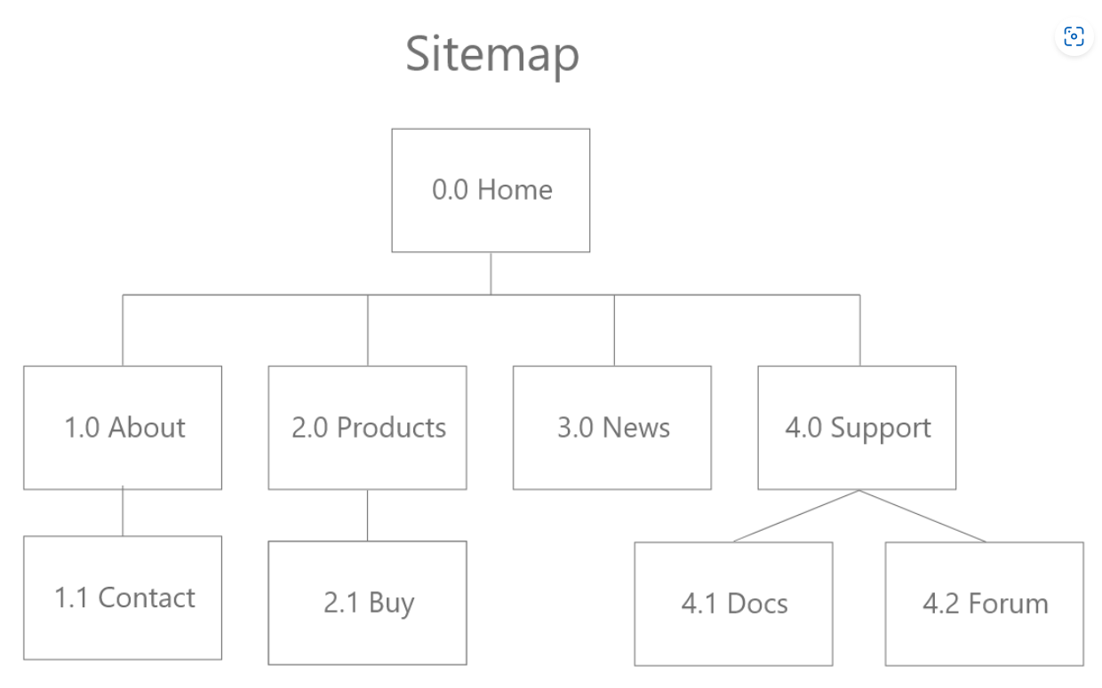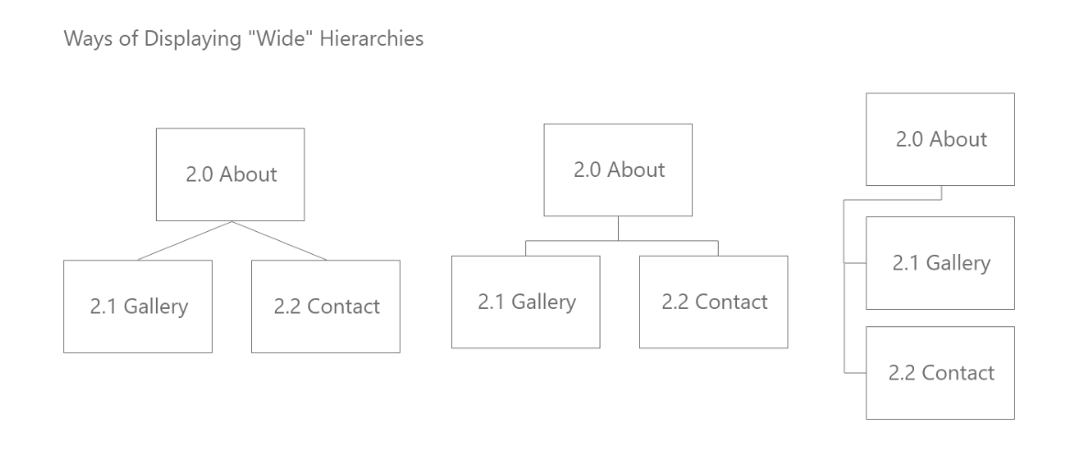

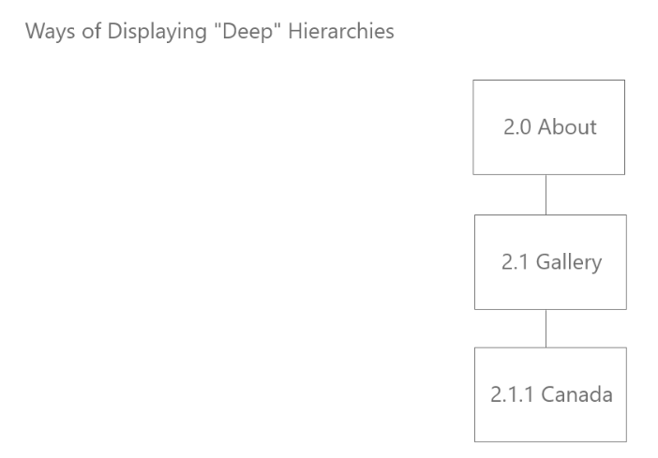

* Card sorting – Write page or content on cards and shuffle into a pile and allow client to organize them logically into sections themselves
* Figma account for creating these Sitemaps:

[Tgj616@uregina.ca](mailto:Tgj616@uregina.ca)

C\*\*\*\*\*\*\*1\*\*\*\*\*

* Part two: Asset Inventory